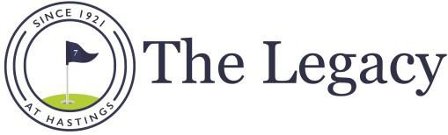
P.O. Box 123 • 1550 N. Broadway • Hastings MI 49058
Office: (269) 945-2756
www.legacyathastings.com
Email: gm@legacyathastings.com
2023 Men’s Monday Golf League

REGISTRATION FORM
- All handicap abilities are welcome and encouraged to participate
- Males 16 years and older are eligible to participate
- We will help you find a partner if you don’t have one

Everyone welcome – you do not have to be a Legacy member to participate

Entry Deadline: Wednesday, April 14th, 2023
League Dates: 20 weeks starting April 17th (2 Fun Nights & 18 weeks of Matches)
Men’s League Format: Four-Ball Match Play (90% Handicap) – Two Men’s League
Participants play their better ball against the better ball of the opposing team.
- Choose your own partner and provide handicap information via GHIN (if not already on record) when submitting the attached entry form.
- If you need a partner, please contact GM at email above

A 3:00p League has been created so please designate if you’d like to play

You are allowed to play in both the 3:00p and 5:30 league

5:30p League is divided into two flights. Both PGA and LIV flights will have a shotgun tee time at 5:30pm.

Winners of both Leagues & Sessions will compete in the end of season playoffs

League Dues:
- Legacy Members –
  - $60 Cost
  - League green fees are included with your membership; $60 per person; All $60 returned in opening night & final awards dinner, prizes & awards.
- Public Participants –
  - $550 Cost (This includes the $60 prize fee that will be returned in opening night & final awards dinner, prizes, & awards)
    - If you can not pay this amount in one payment please email gm to discuss payment plan
- GHIN Handicap Requirement:
  - $30 add-on includes handicap through Golf Association of Michigan, GHIN Official is required

Registration Online Required For All Participants: Click Link Below

Legacy at Hastings Event :: (golfgenius.com)

